1. Download Jmeter from this url (<https://jmeter.apache.org/download_jmeter.cgi> ).
2. Download Binaries .tgz.

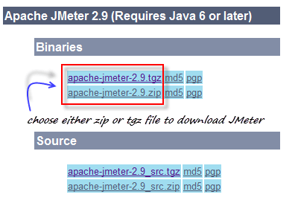

1. Install the Java.
2. Go to your Jmeter bin folder to launch JMeter, in our case it would be C**:\Users\gopi\Downloads\apache-jmeter-3.0\bin** and locate appropriate file.

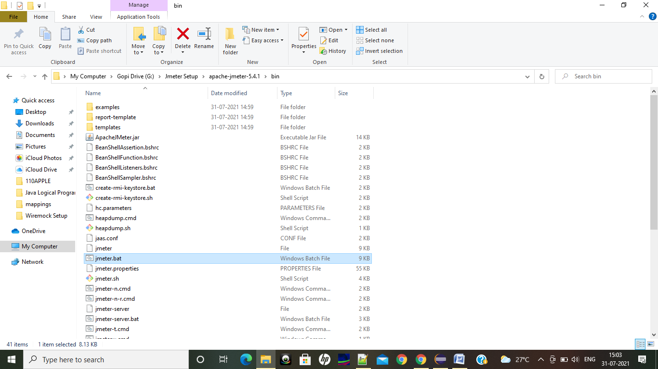

1. After click on the bat file we could see this,

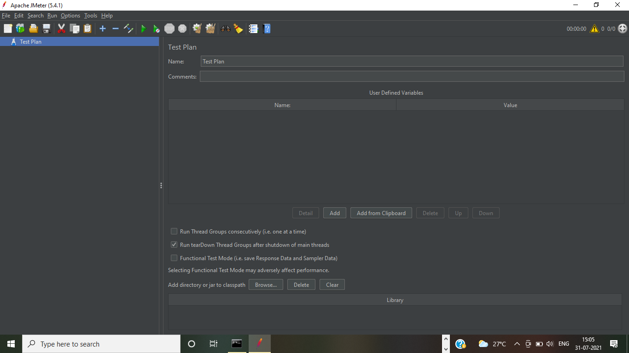

1. Create a thread group under the Test Plan

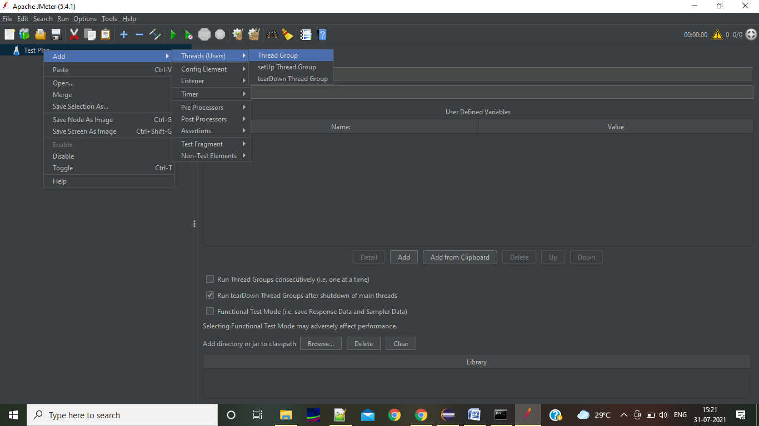

1. Give number of Threads under new Thread Group. If you want to increase the load increase the **Number of Threads(user) count**

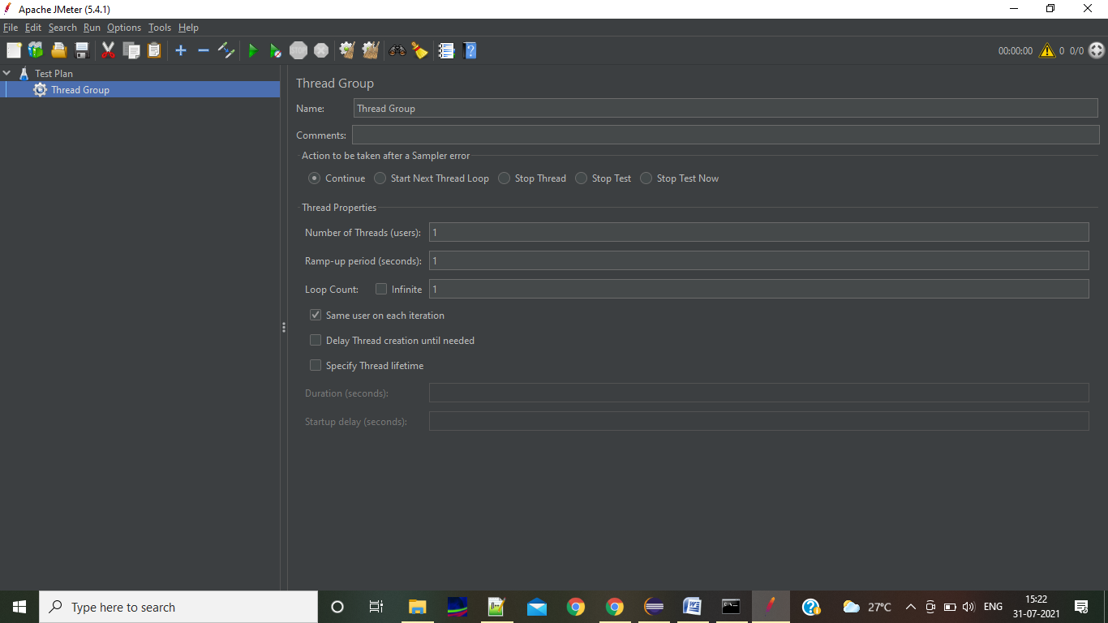

1. Create a Sampler (HTTP Request) in Thread group

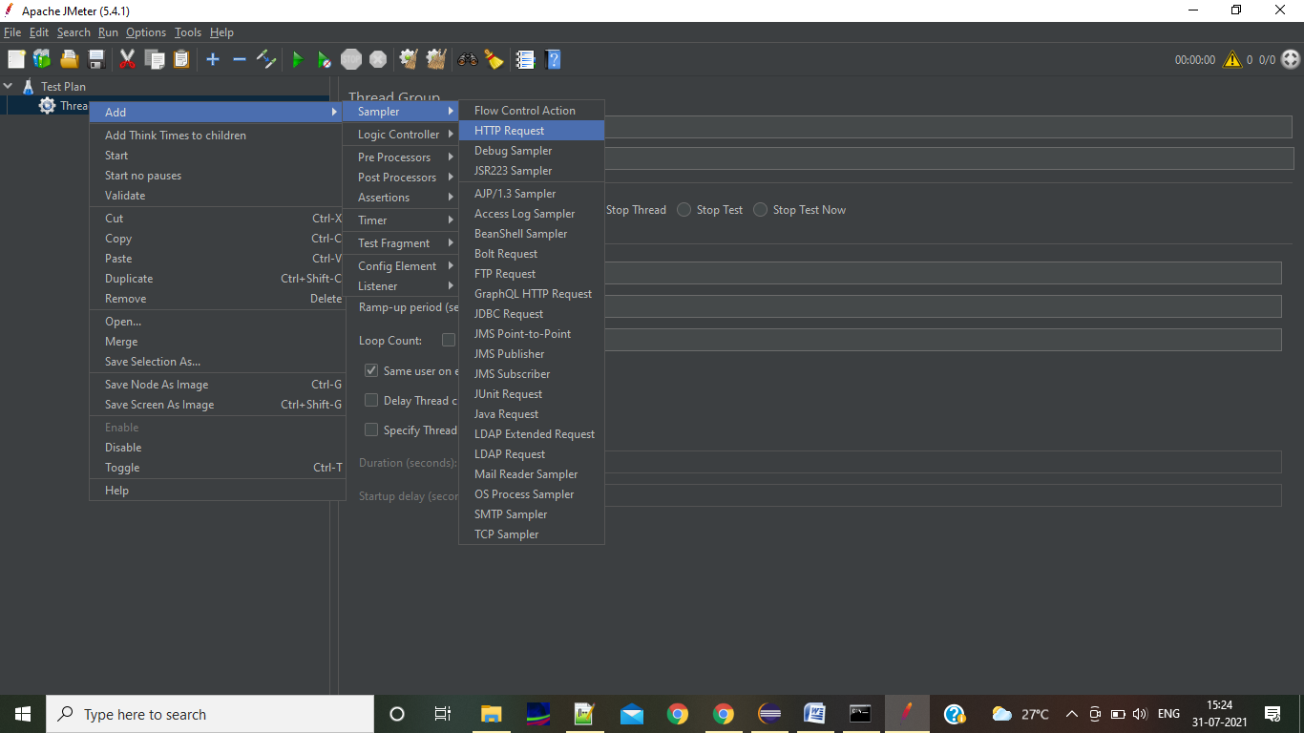

1. In the HTTP request for post request add the below data,

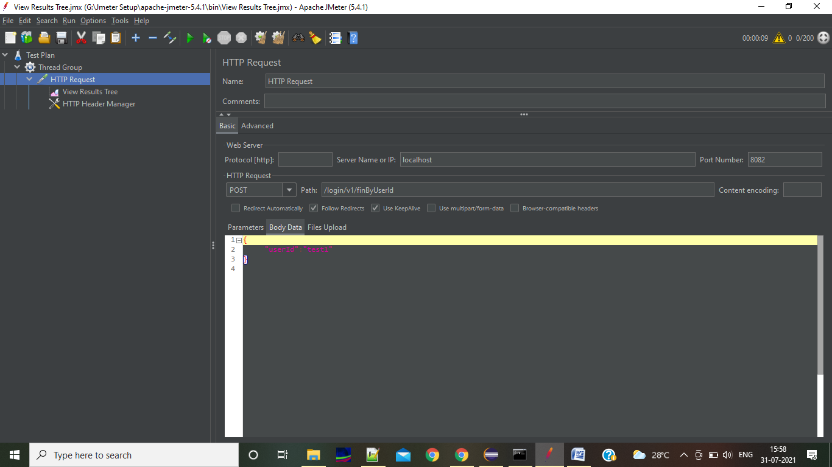

1. In the above screen in the protocol we no need to mention anything. For post request we need to give the input as json request in Body data.
2. If you are doing the post call add the HTTP Manager under HTTP Request. Specify the content type you are sending. Like **application/json**

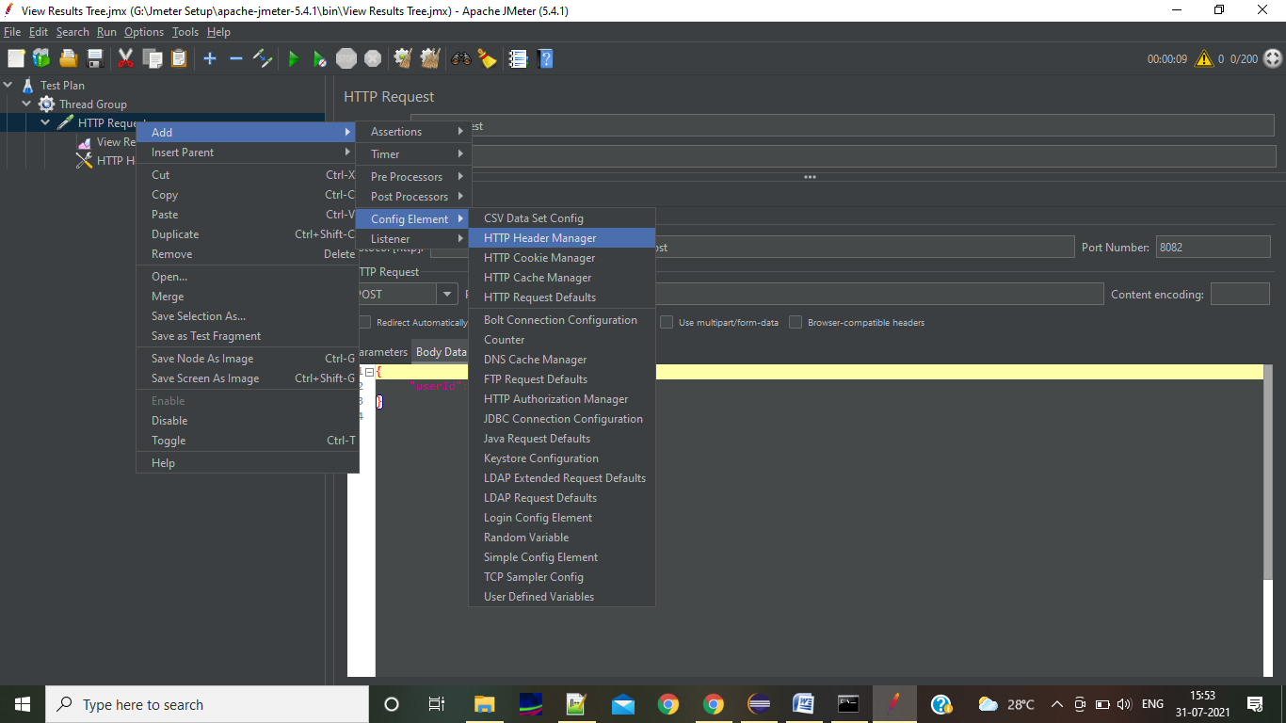

1. Add Listener to view the data in whatever the format you have required

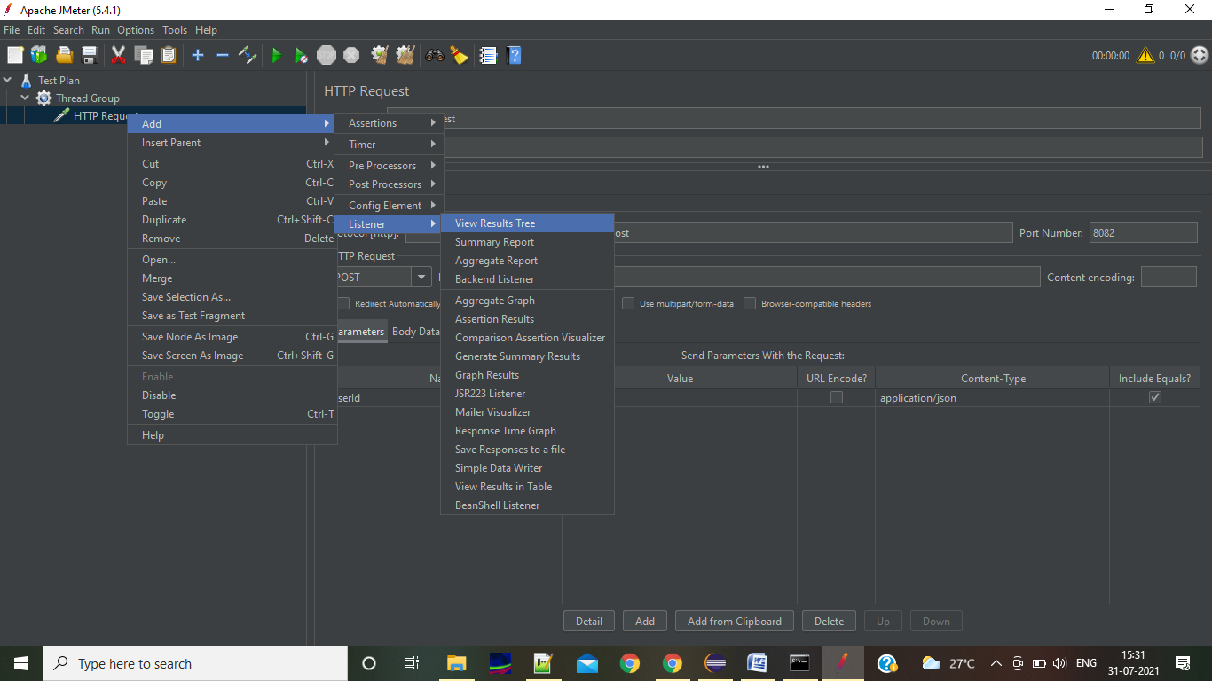

1. After this click on save and save it as **.jmx extension**

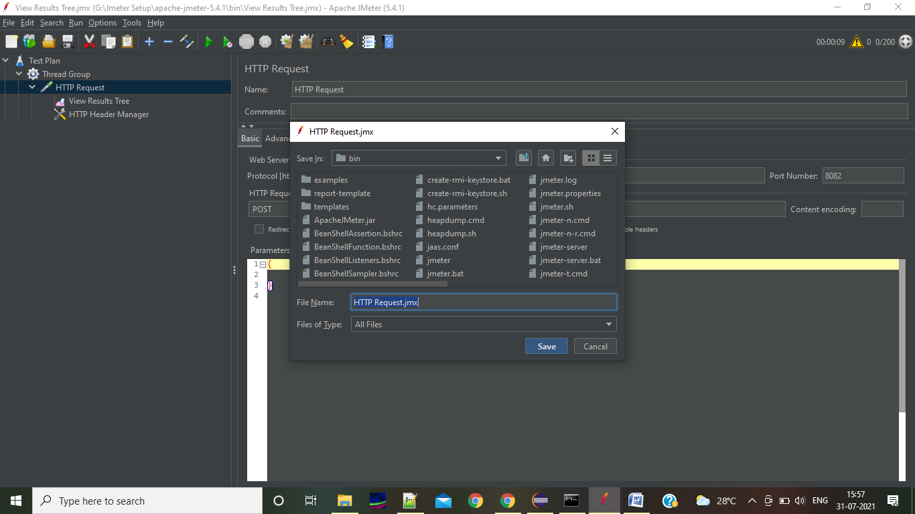

1. Then run the Test Plan. If everything goes fine we could see the success/failure results under View Results tree,

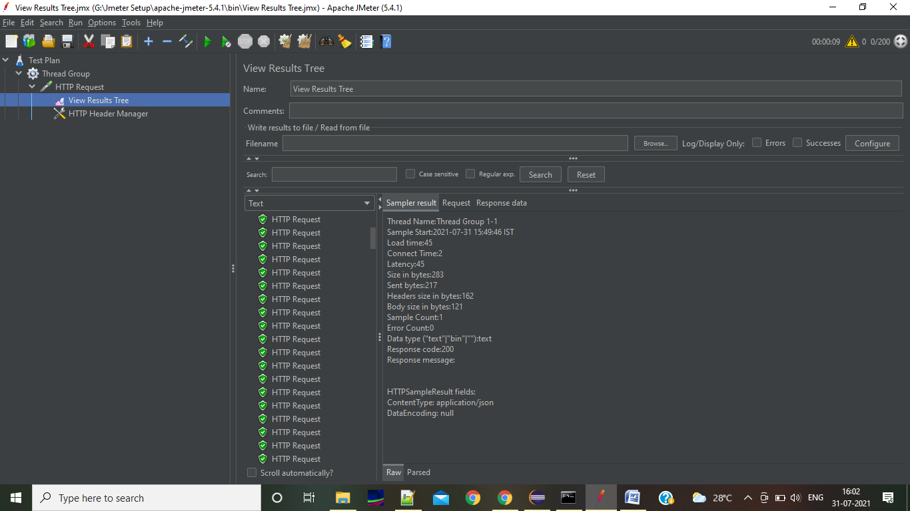

1. We can see the actual request like this in View Results,

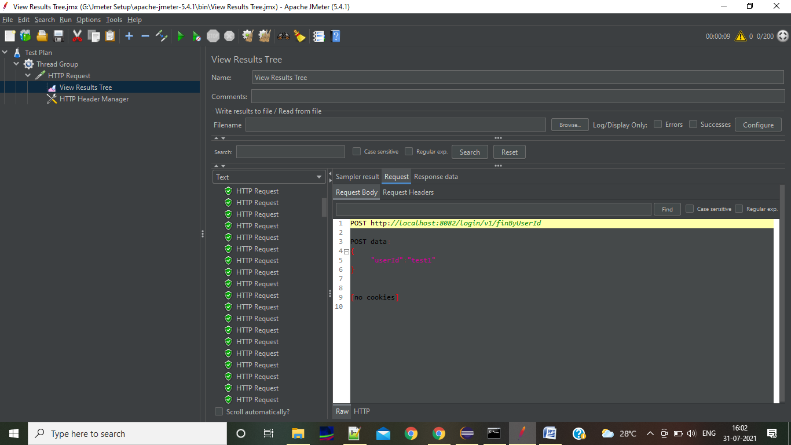

1. We can see the actual response like this in View Results,

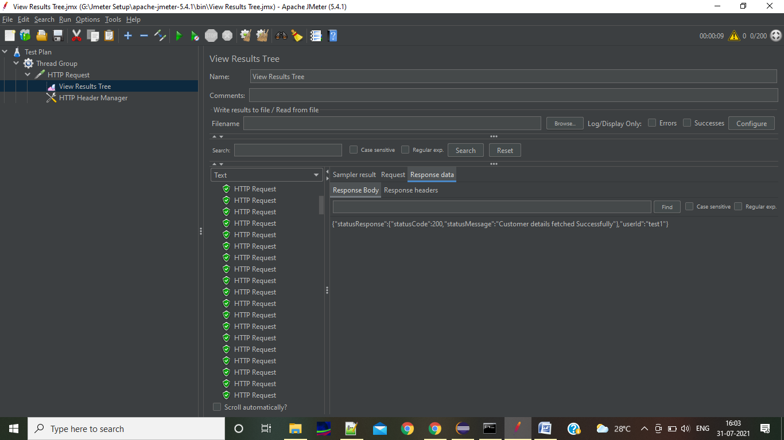

**Best Reference:**

<https://chamikakasun.medium.com/rest-api-load-testing-with-apache-jmeter-a4d25ea2b7b6>

**Graphs Generator:**

<https://www.youtube.com/watch?v=7BuPnFUl2iY>